**Lecture 19**

**LVM5-Structure Backup-Snapshot-RHCSA-PE-Extent-Question**

To extend an LVM 🡪 Vg must have required space

* LVM information or LVM metadata can be corrupt 🡪 chances are high.
* This metadate should be backed up.
* Metadate is created during PV, VG and LV creation 🡪 the metadata is saved in the same LV i.e 1st sector of LVM partition.
* To take its backup 🡪
* VG is important is this scenario because it connects with PV and LV both.
* $ vgcfgbackup <VG_group_name>
* 
* The backup is saved in **“/etc/lvm/backup”**
* LVM has a configuration file too which is in 🡪 **“/etc/lvm/lvm.conf”**
* 
* Here the default location for LVM backup is saved and can be configured accordingly.
* 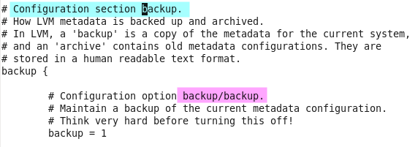
* Remember:- if you don’t want to create LVM on specific drivers (/sda/ sdb/ /sdc ..etc)
* These drivers can be excluded or filteredfrom LVM
* For that, in configuration file of LVM i.e /etc/lvm.conf
* Edit that part 🡪
* Text, letter

  Description automatically generated
* To restore that backup,
* $ vgcfgrestore <VG_name>

**LVM snapshot (very Important)**

To take a snapshot of a Logical Volume (LV) managed by Logical Volume Manager (LVM), you can use the following steps:

1. Identify the LV to be snapshotted: You can use the command **lvdisplay** to list the existing LVs and find the one you want to snapshot.
2. Create the snapshot: Use the command **lvcreate** with the **--size** option to specify the size of the snapshot and the **--snapshot** option to indicate that you're creating a snapshot.

For example, to create a snapshot of an LV named **mylv** with a size of 5G, you can use the following command:

**$ lvcreate --size 5G --snapshot --name mylv-snapshot /dev/myvg/mylv**

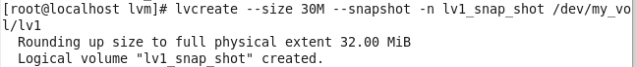

* Where **myvg** is the name of the volume group that contains the LV **mylv**.
* Please note that a snapshot must be smaller than the original LV, and you must have sufficient free space in your volume group to create a snapshot.
* After creating the snapshot, you can use it just like any other LV, for example by mounting it to a directory. However, keep in mind that snapshots are read-only, so you cannot write to them.
* For more information on LVM snapshots, refer to the LVM man pages.
* how to find exact size of LV for snapshot
* **$ lvs -o+size --units=g /dev/myvg/mylv**
* Where **myvg** is the name of the volume group that contains the LV **mylv**. The **--units=g** option specifies that the size should be displayed in gigabytes (GB), and the **-o+size** option ensures that the size is included in the output.
* The output will show the current size of the LV, which you can use when creating the snapshot. For example:
* 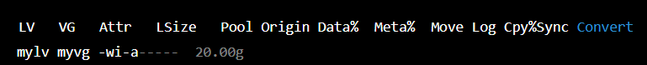
* In this example, the LV **mylv** is 20 GB in size. You can use this information to create a snapshot of a smaller size, ensuring that there is enough space in the volume group to create the snapshot.
* For more information on LVM snapshots, refer to the LVM man pages.
* To list snap shot , command is,
* $ ls /dev/<vg_name>/<snap_shot_name>
* 
* The snapshot is not an entire backup,
* It is just a “pointer” and it is called PIT (Point in Time)
* After that time snapshots also keep increasing as more data is written.
* Most important topics in LVM 🡪 do hands on practice
* 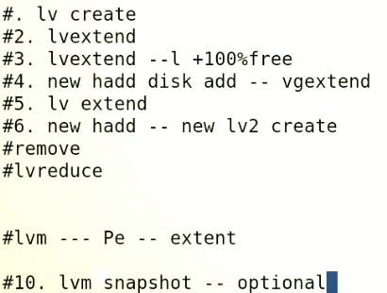

**PE**

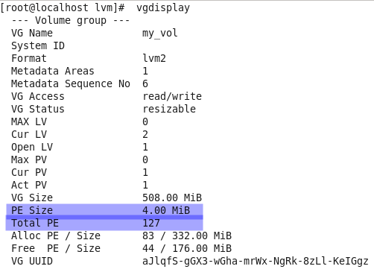

PE stands for "Physical Extent" in LVM (Logical Volume Manager).

LVM is a logical volume management system for Linux that allows you to manage disk storage as logical volumes, rather than as individual physical partitions. In LVM, physical extents (PEs) are the basic unit of disk storage used by LVM. A PE is a contiguous block of disk space, typically 4 MB in size, that is used to allocate space to LVs.

When you create a Logical Volume (LV) in LVM, it is created by allocating a certain number of PEs from one or more Physical Volumes (PVs). The LVs can then be formatted with a file system and used as disk partitions, just like traditional disk partitions.

The size of an LV is determined by the number of PEs it contains, and the size of a PE is determined by the size of the underlying PVs and the physical extent size specified when the volume group was created. The physical extent size can be set to a value between 4 MB and 256 MB.

By using PEs, LVM allows for flexible and dynamic disk management, as you can add or remove PEs from LVs as needed, without having to recreate the LV or the file system on it. This allows you to resize LVs, add more storage to a volume group, or move storage from one LV to another.

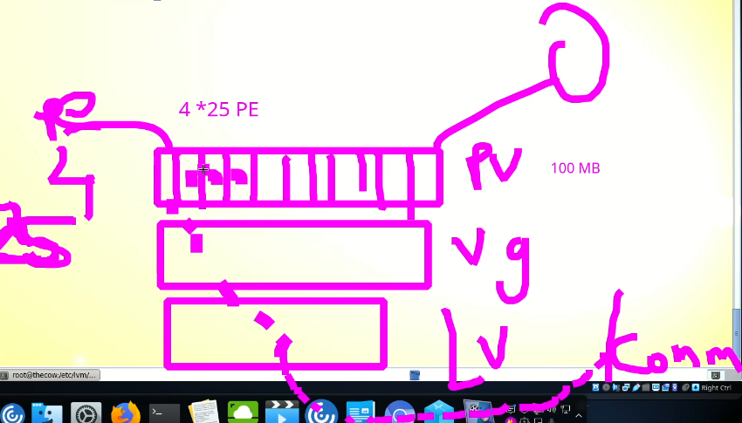

Manipulating Pes and increasing PE size can increase data (input – output) performance.

**LE (Logical Extent) 🡪 in LV**

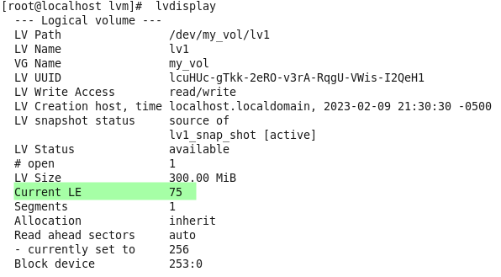

LE stands for "Logical Extent" in LVM (Logical Volume Manager).

LVM is a logical volume management system for Linux that allows you to manage disk storage as logical volumes, rather than as individual physical partitions. In LVM, logical extents (LEs) are the basic unit of disk storage used to represent the size of a Logical Volume (LV).

Each LV is divided into a number of LEs, and each LE is mapped to one or more Physical Extents (PEs), which are the basic unit of disk storage used by LVM. A PE is a contiguous block of disk space, typically 4 MB in size, that is used to allocate space to LVs.

The number of LEs in an LV determines the size of the LV, as each LE is equivalent to a certain number of bytes. The size of an LV can be increased or decreased by adding or removing LEs, respectively. When you add LEs to an LV, LVM allocates additional PEs from one or more Physical Volumes (PVs) to the LV, and maps the new LEs to the new PEs.

By using LEs, LVM allows for flexible and dynamic disk management, as you can resize LVs, add more storage to a volume group, or move storage from one LV to another, without having to recreate the LV or the file system on it.

**Note:- all Pes are connected with Les 🡪 any change in PE size would be reflected to Les as well. So instead of giving size in Mbs no of Pes can also be used while creating logical volumes.**

**Interview Question,**

**What is difference b/w -L and -l**

**-L for size in Mbs or GBs**

**-l is for PEs**

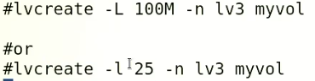

Default size of PE can be changed.

at the time of **“vgcreate”.**

**$ vgcreate -s <PE size i.e 8M> <VG_name> /dev/sdb**

Exact exam question RHCSA,

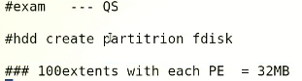

VG step is as below,

Partition should be 4000mb with fdisk

* $ vgcreate -s 32M <vg_name> </dev/sdx>
* $ lvcreate -l 100 -n mylv1 <dev/<vg_name>

